**1. CRM and Branch Network Management**

**2. Checking Accounts and Savings Accounts**

**(Presented By Alan Stuart K)**

**1. CRM and Branch Network Management:**

**Introduction:**

Customer Relationship Management (CRM) and Branch Network Management are essential components of modern banking operations. CRM focuses on understanding and fulfilling the needs of customers to enhance satisfaction, loyalty, and profitability. Branch Network Management involves optimizing the physical and digital presence of bank branches to provide accessible, efficient, and personalized services.

**Insights:**

1. **Integration of Technology:** Advanced CRM systems integrate with various digital channels (mobile, web, social media) to provide a seamless customer experience. These systems leverage data analytics, AI, and machine learning to gain insights into customer behaviour and preferences.
2. **Omnichannel Strategy:** Effective branch network management combines physical and digital channels to meet customers where they are. This involves the strategic placement of branches and ATMs, as well as the use of digital platforms to provide 24/7 access to banking services.
3. **Personalization:** CRM tools enable banks to offer personalized services and products based on customer data. Personalized marketing campaigns, tailored financial advice, and customized product offerings improve customer engagement and loyalty.
4. **Efficiency and Cost Reduction:** Optimizing the branch network can lead to significant cost savings. By analysing foot traffic, transaction data, and customer preferences, banks can make data-driven decisions about branch openings, closures, and relocations.

**Use Cases and Applications:**

1. **Customer Segmentation and Targeting:** CRM systems help banks segment their customer base by demographics, behaviour, and profitability. This enables targeted marketing campaigns and personalized service offerings.
2. **Enhanced Customer Service:** CRM tools track customer interactions and preferences, allowing bank staff to provide more informed and efficient service. For example, a customer service representative can access a customer's history to resolve issues quickly and offer relevant solutions.
3. **Branch Optimization:** Using data analytics, banks can determine the optimal locations for branches and ATMs, ensuring they are accessible to the most customers. This includes analysing population density, economic activity, and competition.
4. **Performance Monitoring:** Branch network management involves regular performance assessments to ensure branches are meeting service standards and financial targets. Metrics such as customer satisfaction scores, transaction volumes, and profitability are monitored and analysed.
5. **Digital Transformation:** Implementing digital solutions like virtual branches, online banking, and mobile apps extends the bank’s reach and provides convenience to customers. CRM systems support these digital channels by maintaining consistent and accurate customer data across all touchpoints.

**Data:**

| **Bank** | **Number of Branches** | **Number of Active Customers** | **Customer Satisfaction Score** |
| --- | --- | --- | --- |
| **JPMorgan Chase** | **4,976** | **66,000,000** | **4.2 / 5** |
| **Bank of America** | **4,300** | **66,000,000** | **4.0 / 5** |
| **Wells Fargo** | **4,900** | **70,000,000** | **3.8 / 5** |
| **Citigroup** | **689** | **110,000,000** | **4.1 / 5** |
| **U.S. Bancorp** | **2,755** | **18,000,000** | **4.3 / 5** |

**2. Checking Accounts and Savings Accounts:**

**Introduction:**

Checking accounts and savings accounts are fundamental financial products offered by banks to meet the everyday banking needs of individuals and businesses. Checking accounts are designed for frequent transactions and easy access to funds, while savings accounts are intended for storing money and earning interest over time.

**Insights:**

1. **Liquidity and Accessibility:** Checking accounts provide high liquidity, allowing customers to write checks, use debit cards, and make electronic transfers with ease. Savings accounts, while less liquid, encourage saving by offering interest on deposits and limiting withdrawals.
2. **Interest and Fees:** Checking accounts typically offer little to no interest but may come with fees for maintenance, overdrafts, and other services. Savings accounts usually provide interest on deposits, with higher balances often earning higher rates. Some savings accounts also have withdrawal limits to encourage saving.
3. **Purpose and Usage:** Checking accounts are used for day-to-day expenses, bill payments, and direct deposits. Savings accounts are used for emergency funds, specific savings goals, and accumulating wealth over time.

**Use Cases and Applications:**

1. **Daily Transactions:** Checking accounts are ideal for managing daily expenses such as groceries, utilities, rent, and other regular payments. They offer features like online bill pay, mobile check deposit, and automatic payments.
2. **Emergency Fund:** A savings account is a suitable place to keep an emergency fund, ensuring that money is available when unexpected expenses arise, such as medical bills or car repairs. The interest earned can help the fund grow over time.
3. **Saving for Goals:** Customers can use savings accounts to set aside money for specific goals like a vacation, home purchase, or education expenses. Some banks offer tools to help track and manage savings goals within the account.
4. **Overdraft Protection:** Many banks offer overdraft protection services that link a savings account to a checking account. If the checking account balance falls below zero, funds are automatically transferred from the savings account to cover the shortfall.
5. **Interest-Bearing Checking Accounts:** Some banks offer checking accounts that earn interest, combining the benefits of easy access to funds with the ability to earn a return on the balance. These accounts typically require maintaining a higher minimum balance.

**Data:**

| **Bank** | **Checking Account Interest Rate** | **Savings Account Interest Rate** | **Total Deposits (Billions)** |
| --- | --- | --- | --- |
| **JPMorgan Chase** | **0.01%** | **0.05%** | **$2,035** |
| **Bank of America** | **0.01%** | **0.03%** | **$1,879** |
| **Wells Fargo** | **0.01%** | **0.02%** | **$1,436** |
| **Citigroup** | **0.01%** | **0.04%** | **$1,319** |
| **U.S. Bancorp** | **0.01%** | **0.02%** | **$429** |

**Graphs:**

**Graph 1:** JPMorgan Chase Stock Price (Proxy for CRM & Branch Network):

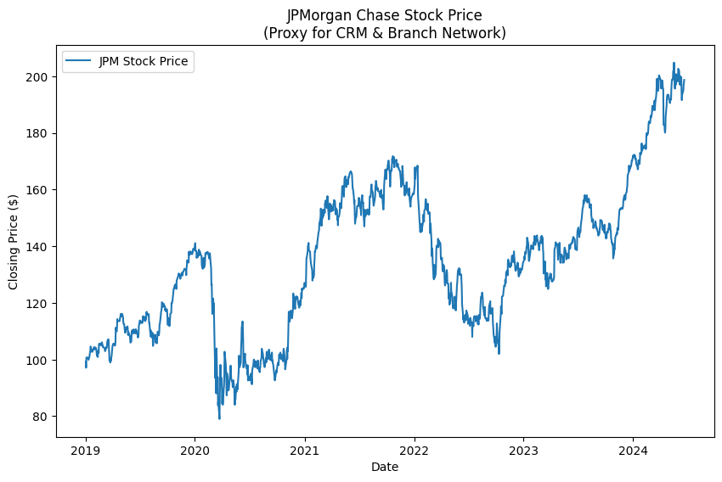**Inference:** This graph uses JPMorgan Chase's stock price as a proxy to assess the value and performance of the bank's customer relationship management (CRM) and branch network. The underlying assumption is that the stock price reflects the market's perception of the bank's overall performance, including its ability to effectively manage customer relationships and optimize its branch network. By analysing the stock price graph, stakeholders can gain insights into the market's assessment of JPMorgan Chase's CRM and branch network performance over time.

**Graph 2:** 3-Month Treasury Bill Rate (Proxy for Checking & Savings Rates):

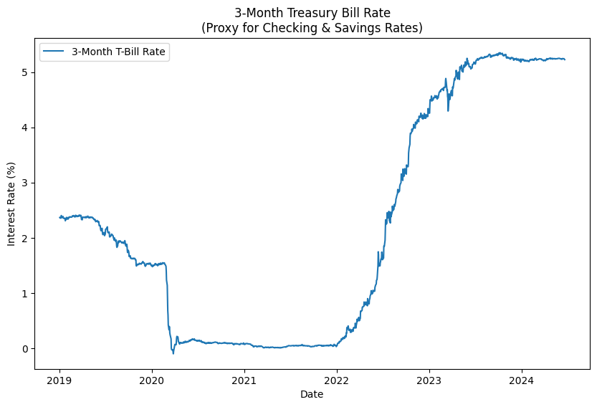

**Inference:** This graph uses the 3-month Treasury bill rate as a proxy for the interest rates offered on checking and savings accounts. Treasury bill rates are often used as a benchmark for short-term interest rates in the economy, and banks typically consider these rates when setting their own deposit rates. By examining the 3-month Treasury bill rate graph, banks can assess the general direction and level of short-term interest rates, which can inform their deposit pricing strategies. 3-month Treasury bill rate can serve as proxies for evaluating the performance of CRM and branch networks, as well as the dynamics of checking and savings account rates.

**Graph 3:** Comparative Stock Performance:

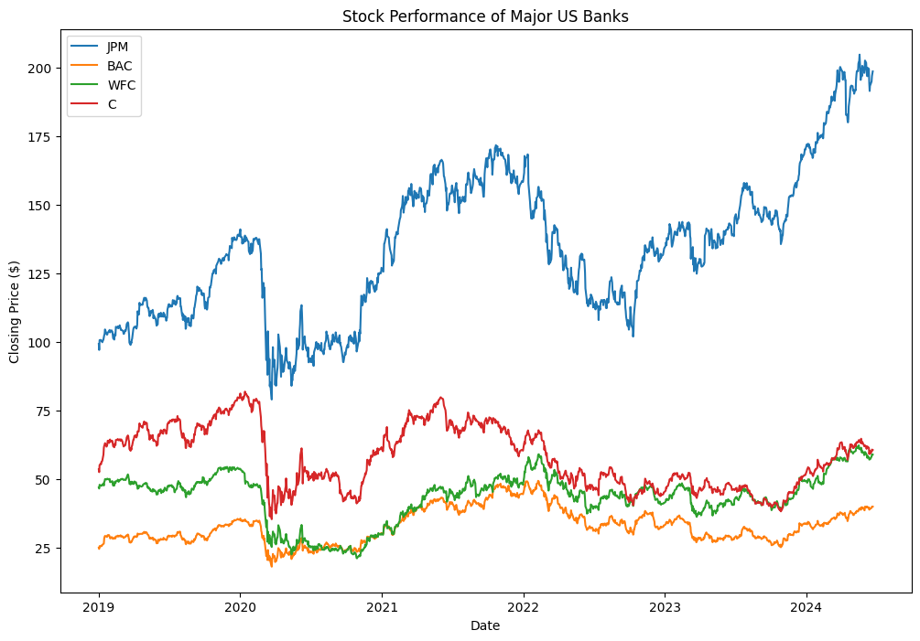**Inference:** This graph compares the stock price performance of major US banks (JPMorgan Chase, Bank of America, Wells Fargo, and Citigroup) over the past 5 years. It provides insights into the relative performance and trends of these banks. For example, if one bank's stock consistently outperforms the others, it may indicate better management, profitability, or market perception. Divergences between the banks' stock prices could also signal differences in their business models, risk exposures, or responses to economic events.

**Graph 4:** A correlation heatmap of the banks' stock returns:

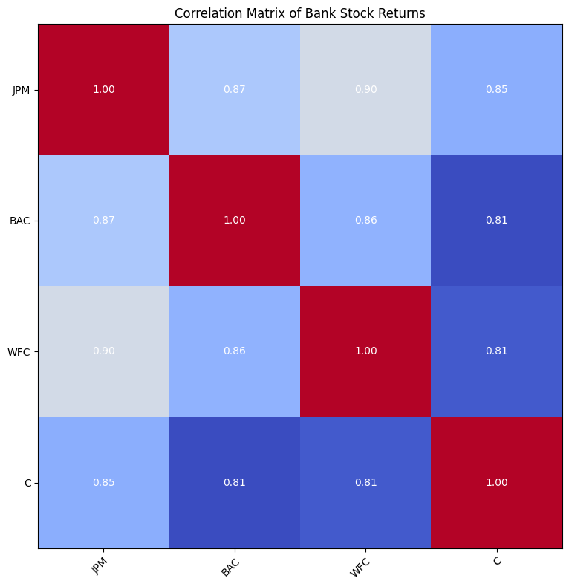**Inference:** The correlation heatmap visualizes the relationships between the stock returns of the major US banks. It helps identify potential similarities or differences in how these banks' stocks move in relation to each other. High positive correlations (red) suggest that the banks' stock prices tend to move in the same direction, which could be due to shared market conditions or sector-specific factors. Low or negative correlations (blue) indicate that the banks' stocks may behave differently, possibly due to bank-specific characteristics or strategies.

**Graph 5:** A spread plot comparing 2Y Treasury yields to a savings account proxy rate (3M T-bill):

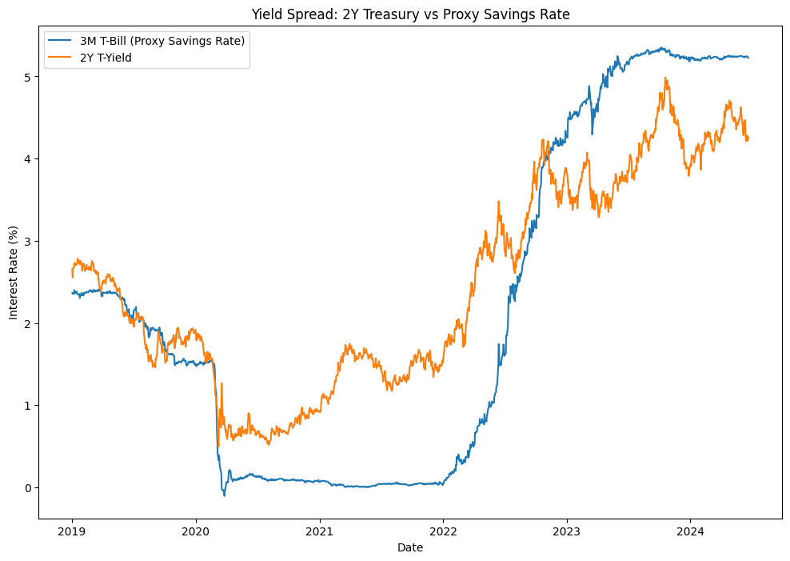**Inference:** 2Y Treasury vs Proxy Savings Rate: This graph compares the 2-year Treasury yield to a proxy savings rate (3-month Treasury bill rate). The spread between these rates can provide insights into the attractiveness of savings accounts relative to other short-term investment options. A higher spread suggests that savings accounts may offer better returns compared to short-term government bonds. Conversely, a narrowing or negative spread could indicate that savings accounts are becoming less attractive. This information is relevant for banks in setting competitive rates and managing their deposit bases.

**Graph 6:** Bank stock performance relative to the S&P 500 index:

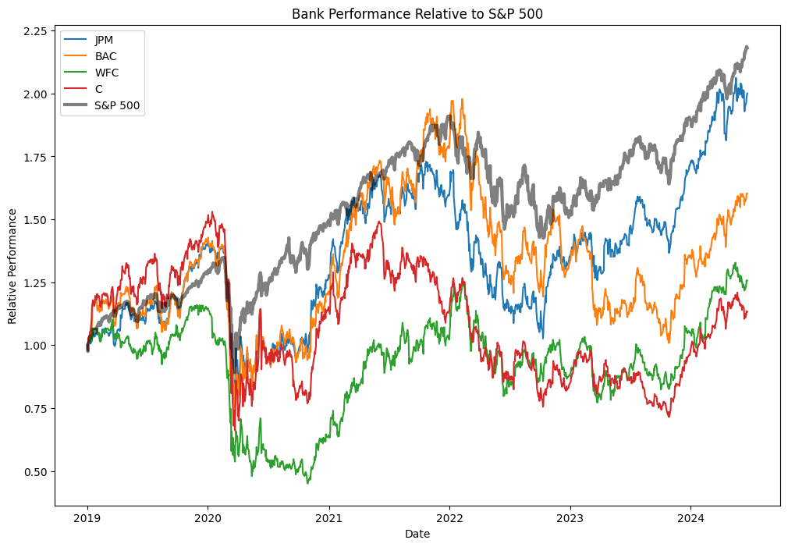

**Inference:** This graph shows the performance of major US bank stocks relative to the S&P 500 index. It helps assess whether the banks are outperforming, underperforming, or moving in line with the broader market. Outperformance could suggest that the banking sector is doing well compared to other sectors, while underperformance may indicate sector-specific challenges. This relative performance analysis is useful for investors in making sector allocation decisions and for banks in benchmarking their stock performance.

**Graph 7:** A comparison of 30-day rolling volatility between banks and major market indices:

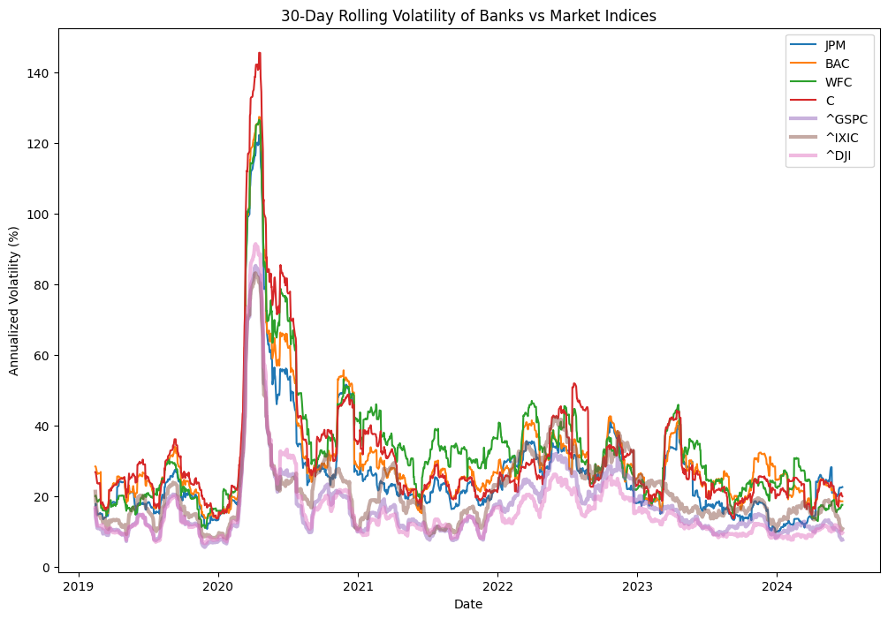**Inference:** This graph compares the 30-day rolling volatility of major US banks and market indices (S&P 500, NASDAQ, Dow Jones). Volatility is a measure of the price fluctuations and risk associated with these assets. Higher volatility suggests greater uncertainty and potential for larger price swings. By comparing the banks' volatility to market indices, we can assess whether the banking sector is experiencing higher or lower risk compared to the overall market. This information is valuable for risk management and investment decisions.

**Graph 8:** A visualization of deposit growth over time:

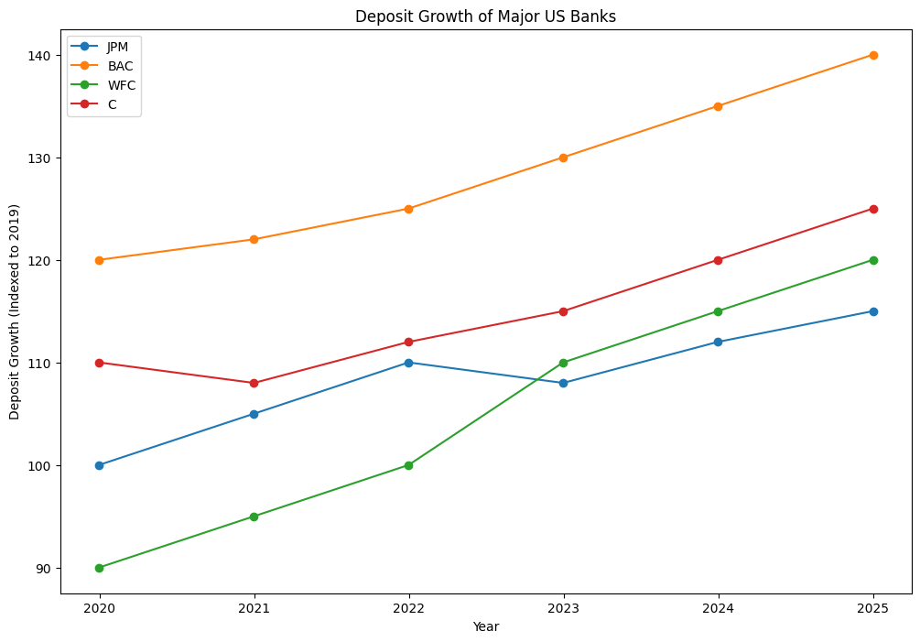**Inference:** This graph visualizes the deposit growth of major US banks over time. Deposit growth is a key metric for banks as it reflects their ability to attract and retain customer deposits, which are a crucial funding source. Steady deposit growth may indicate customer confidence, effective marketing, or attractive product offerings. Divergences in deposit growth among banks could highlight differences in their strategies or market positions. This information is important for assessing banks' financial stability and competitive dynamics.

**Conclusion:**

CRM and Branch Network Management, along with Checking and Savings Accounts, are pivotal to the success and efficiency of modern banking. By leveraging advanced CRM systems, banks can gain deep insights into customer behaviour, enabling personalized service and targeted marketing that enhance customer satisfaction and loyalty. Branch Network Management optimizes the distribution of physical and digital banking channels, ensuring accessibility and operational efficiency, thus balancing cost reduction with customer convenience. Checking accounts facilitate seamless daily transactions with high liquidity and accessibility, while savings accounts encourage financial growth through interest earnings and disciplined saving for future goals. Together, these elements form the backbone of effective banking strategies, driving customer engagement, operational efficiency, and financial stability.